**Weekly Status Report - 2018-05-07**

|  |  |
| --- | --- |
| **Project Name** | MLIK |
| **Team Lead** | Ashleigh Logan |

|  |  |  |  |  |
| --- | --- | --- | --- | --- |
| **Roles** |  |  |  |  |
| **Week** | **Ashleigh Logan** | **Brendon Waters** | **Isaac Thiessen** | **Jacob Warnes** |
| 01 | Team Lead, Technical Writer, Database/Back-End | Front-End Developer, Technical Writer, Database/Back-End Developer | Technical Writer, Database/Back-End Developer | Technical Writer, Database/Back-End Developer |
| 02 |  |  |  |  |
| 03 |  |  |  |  |
| 04 |  |  |  |  |
| 05 |  |  |  |  |
| 06 |  |  |  |  |
| 07 |  |  |  |  |
| 08 |  |  |  |  |

|  |
| --- |
| **Weekly Project Summary** |
| Status: on time. Met all goals and deadlines, no issues from previous week.  Completed all tasks before end of day on Tuesday, 15th. |

|  |  |  |  |  |  |
| --- | --- | --- | --- | --- | --- |
| **Key Milestones Status** | | | | | |
| **ID** | **Description** | **Planned Completion** | **Forecasted**  **Completion** | **Actual Completion** | **Status** |
| 19 | Demo and Deliverables Completed | 2018-05-15 | 2018-05-15 | 2018-05-15 | Complete |
| 26 | Demo and Deliverables Completed | 2018-05-22 | 2018-05-22 |  | Incomplete |
| 32 | Demo and Deliverables Completed | 2018-05-29 | 2018-05-29 |  | Incomplete |
| 38 | Demo and Deliverables Completed | 2018-06-05 | 2018-06-05 |  | Incomplete |
| 44 | Demo and Deliverables Completed | 2018-06-11 | 2018-06-11 |  | Incomplete |
| 50 | Demo and Deliverables Completed | 2018-06-18 | 2018-06-18 |  | Incomplete |
| 56 | Demo and Deliverables Completed | 2018-06-22 | 2018-06-22 |  | Incomplete |
| 58 | Final Presentation | 2018-06-22 | 2018-06-22 |  | Incomplete |
| 59 | Final Report | 2018-06-22 | 2018-06-22 |  | Incomplete |

|  |
| --- |
| **Key Accomplishments for the Week** |
| 19 - Demo and Deliverables Completed |

|  |  |  |  |
| --- | --- | --- | --- |
| **Task Assignments for the Coming Week** | | |  |
| **ID** | **Description** | **Assigned To** | **On Schedule** |
| 21 | Git Repository Report | Isaac | Yes |
| 22 | Complete Task Log | Brendon | Yes |
| 23 | Update Weekly Status Report | Brendon | Yes |
| 24 | HTML Mockup | Ashleigh, Brendon | Yes |
| 26 | Demo Scheduled | Brendon | Yes |

|  |  |  |
| --- | --- | --- |
| **Tasks Completed in the Previous Week** | |  |
| **ID** | **Description** | **Assigned To** |
| 3 | Gantt Chart & Scheduling | Brendon, Ashleigh |
| 4 | Project Charter | Ashleigh |
| 5 | BRD | Ashleigh, Isaac, Jacob |
| 13 | Initial Website Design | Brendon |
| 14 | UI Mock-up | Brendon |
| 15 | Database Design | Ashleigh, Brendon, Isaac, Jacob |
| 16 | Complete Task Log | Ashleigh |
| 17 | Update Weekly Status Report | Ashleigh |
| 18 | Demo Scheduled | Ashleigh |

|  |  |
| --- | --- |
| **Issues and Risks** |  |
| **Description** | **Impact**  **(L,M,H)** |
| Project tasks for upcoming week may not be distributed evenly | L |
|  |  |

|  |
| --- |
| **Gantt Chart** |

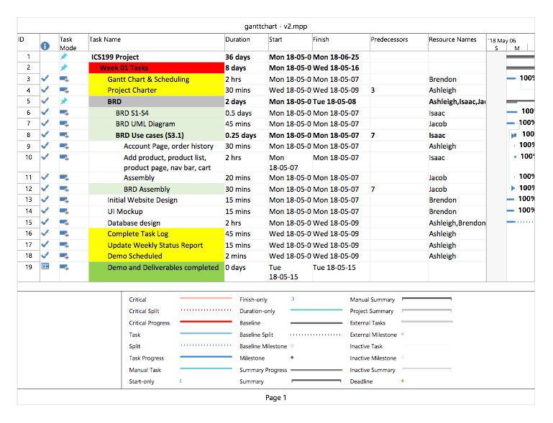

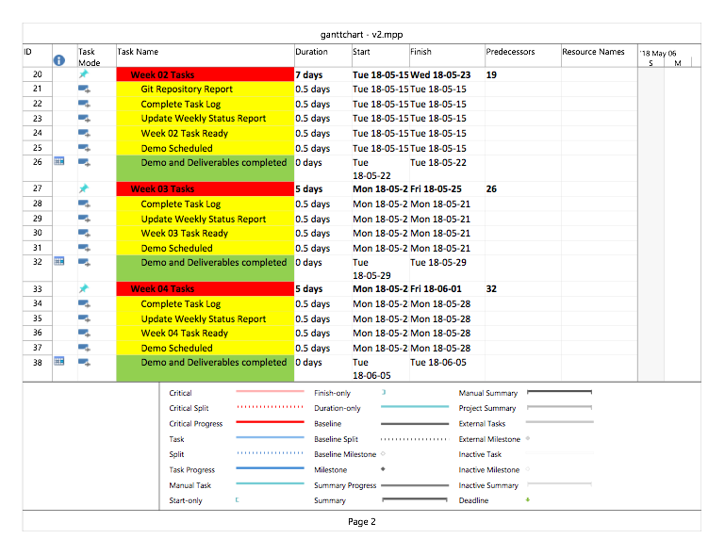

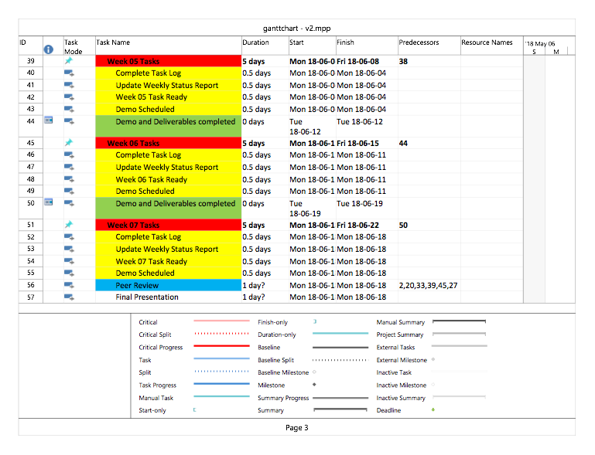

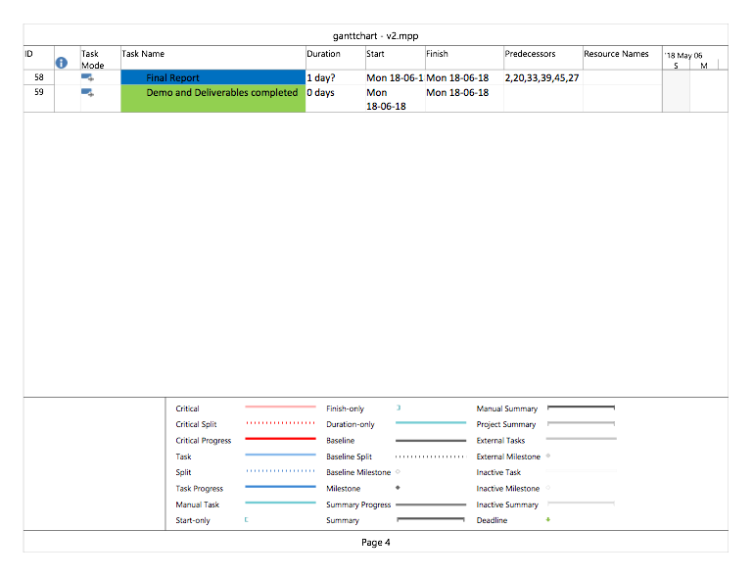

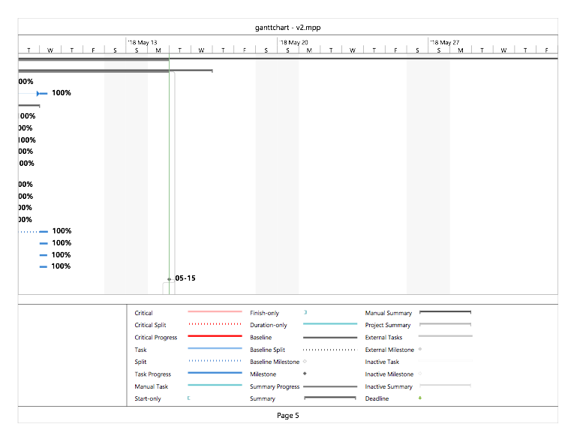

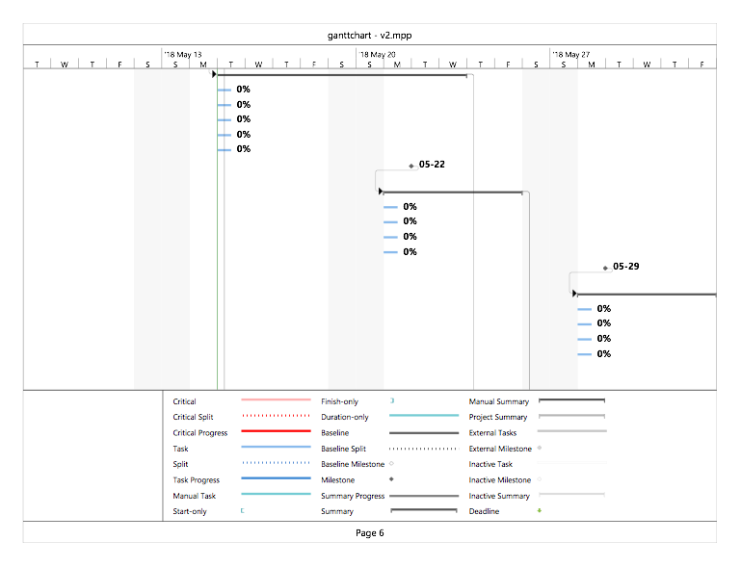

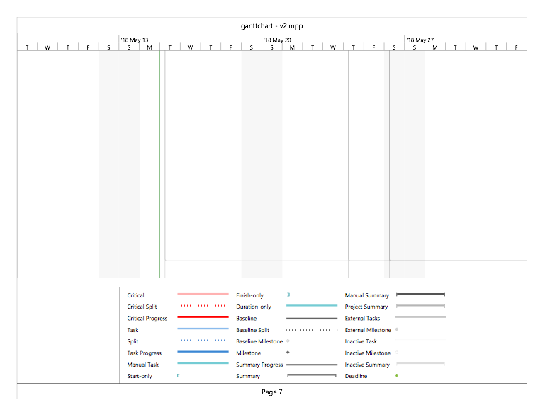

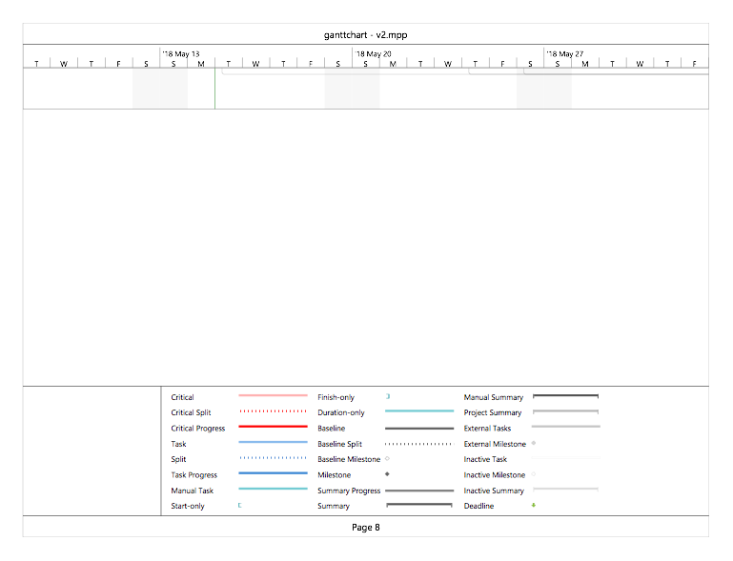

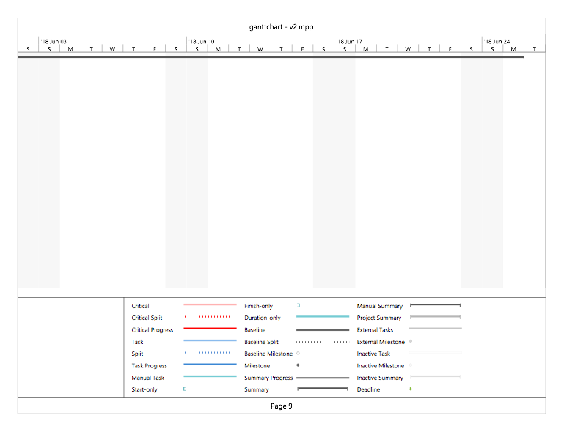

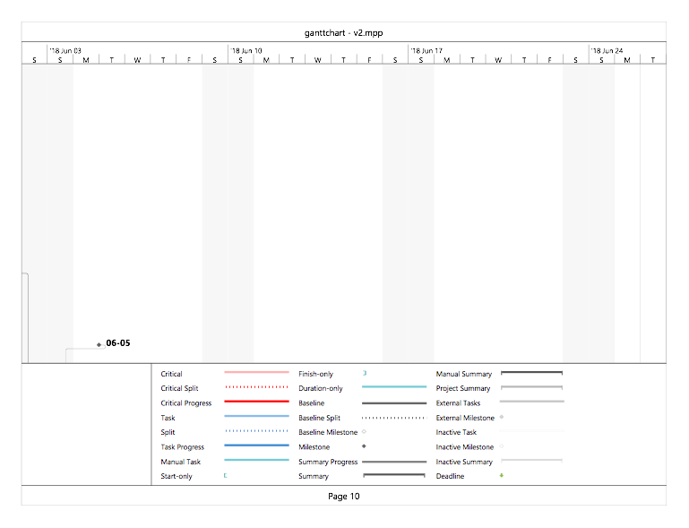

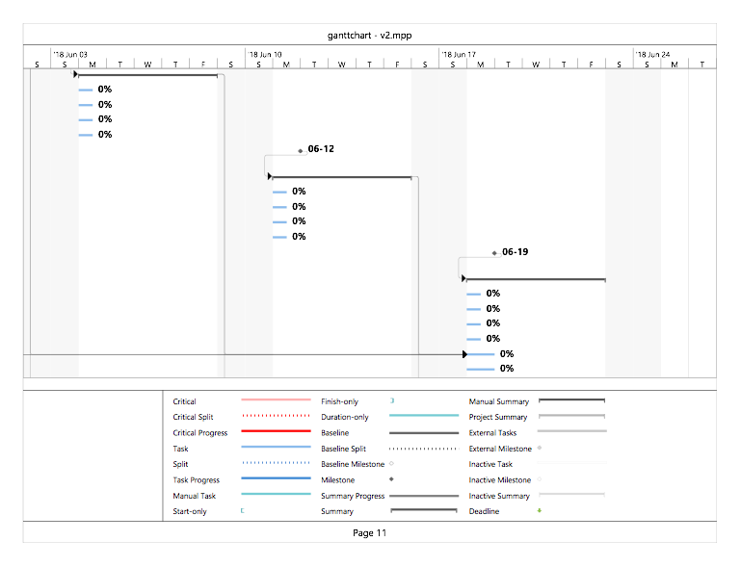

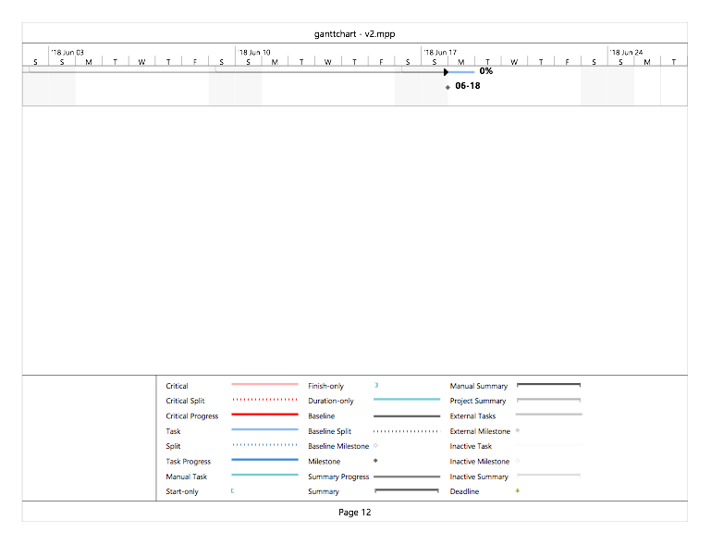

|  |
| --- |
| **Git Log** |

*< Insert Git Log here, use the following command*

*git log --since=1.week --pretty=format:"%an: %s"*

*>*